Lesson 5 : Percentages II (B)
Answer

Checkpoint 1

The price of a car is $100 000 in 2019, knowing that the price will increase steadily at a rate of 2% each year. Find it’s price in 2022.

Year | Price ($)
2019 | $$100000$$
2020 | $$100000(1+2\%)$$
2021 | $100000(1+2\%)(1+2\%)$ = $100000{(1+2\%)}^{2}$
2022 | $100000(1+2\%)(1+2\%)(1+2\%$) = $100000{(1+2\%)}^{3}$
So, after n years , the price will be $100000{(1+2\%)}^{n}$, n = period內計算次數

1. The population of town A is 200 000 now and it grows at a rate of 2 % per year. Find its population after 2 years.

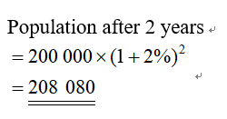
Q1-5
Percentage problem with constant rate

2. Oscar weighted 80 kg in the year 2008. His weight increases steadily at a rate of 5.5% each year. Find his weight in 2011 correct to the nearest 0.1 kg.

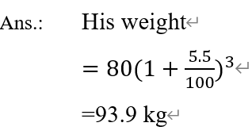

3. The value of a photocopier is $180 000 now. If the depreciation rate of the photocopier is 15% each year, find
(a) the value of the photocopier after 3 years,
(b) the depreciation of the photocopier after 3 years.

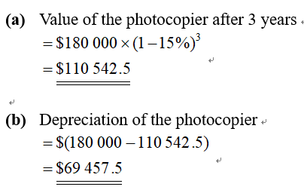


4. A certain kind of bacteria increases their number at a constant rate of 100% every 2 minutes. If there are 10 bacteria initially, how many bacteria will there be after 12 minutes?

Hint : During 12 minutes period, how many times it has increased ?
No. of bacteria after $12$ mins. $=10{\left(1+\frac{100}{100}\right)}^{6}=640$

5. The value of a mobile phone depreciates 30% every half year, find the price of the mobile phone after 2 years if the original price is $2 580.

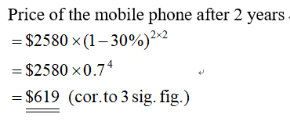

For grow at a rate of n%
$$\text{Growth factor}= \text{1}+\frac{n}{\text{100}}$$
For decrease at a rate of n%
$$\text{Decay factor}= \text{1}-\frac{n}{\text{100}}$$

6. A tree of 3 m tall grows at a rate of 20% per year. Find
(a) the growth factor,
(b) the height of the tree after 4 years.

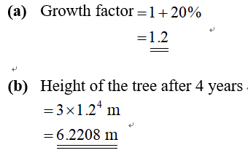


7. The value of a television is $12 000 now. If the value of the television depreciates 20% each year, find
(a) the decay factor,
(b) the value of the television after 4 years.

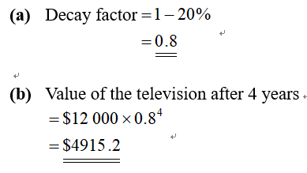
Q6-7
Percentage problem with constant rate
(with growth/decay factor)

Checkpoint 2

A stamp is worth $450 this year. If its value increases at a rate of 15% every year, find the value $x of the stamp 3 years ago.

Let $x$ be $The price 3 years ago,$
$$∴The price 3 years ago,$$
$$x{\left(1+15\%\right)}^{3}=450$$
$$x(1.520875)=450$$
$$x=296$$
$$∴The price of a stamp is \$296 in 3 years ago,$$

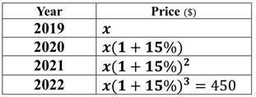

8. The value of a computer depreciates 25% each year. If the value of the computer is $3 940 now, find the value of the computer 2 years ago.

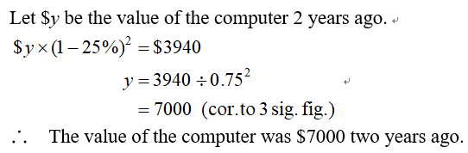
Q8-13
Percentage problem with constant rate
(find the original number)

9. A machine is worth $120 000 now and its depreciation rate is 10% per year. Find its value
(a) after 2 years,
(b) 2 years ago.

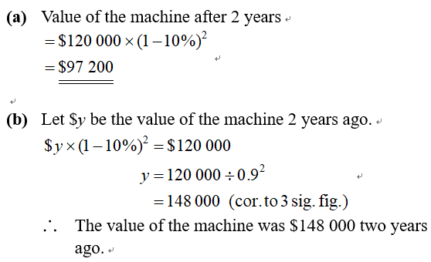


10. Mr Chan spent $350 000 to buy an antique note 2 months ago. If the value of the note increased at the rate of 8% per month, find the value of the antique note
(a) now,
(b) 5 months ago.

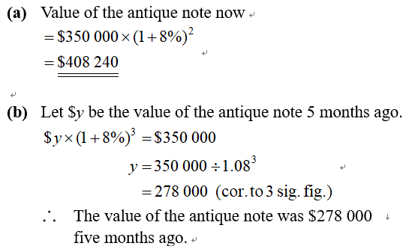


11. The annual profit of a company decreased steadily at a rate of 10% each year before 2011 but increased steadily at a rate of 10 % each year after 2011. If the annual profit of the company was $145 800 in 2011, find its annual profit in the year
(a) 2008,
(b) 2014

(a) Annual profit in 2008 $=\$145800÷{\left(1-\frac{10}{100}\right)}^{3}=\$200000$

(b) Annual profit in 2014 $=\$145800{\left(1+\frac{10}{100}\right)}^{3}=\$194059.8$

12. The monthly salary of Alex is $22 000 this year. If his monthly salary increases at a rate of 8% each year, find
(a) his monthly salary 4 years ago,
(b) the overall increase in his monthly salary in these 4 years.

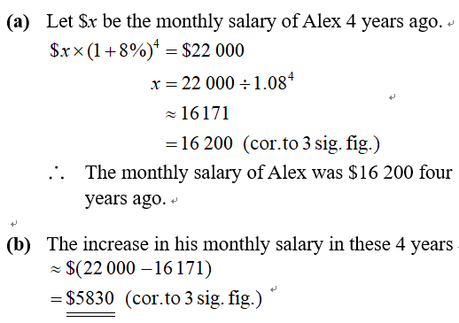


13. The value of a mobile phone depreciates 12% each month. If the value of the mobile phone is $3 700 now, find
(a) the value of the mobile phone 3 months ago,
(b) the overall decrease in the value of the mobile phone in these 3 months.

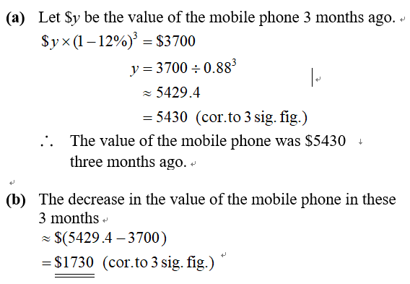

14. The value of a flat is $4 200 000 now. It increases at a rate of 8% for the first year and 5% for every subsequent year. Find its value
(a) after 1 year,
(b) after 3 years.

Q14-17
Percentage problem with constant rate
and different rate
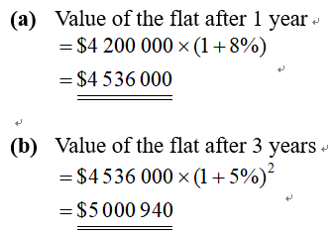


15. The value of a certain index is $28 000 now. Its value is increased by 15% in the first year and decreased by 4% for every subsequent year. Find
(a) the value of the index after 4 years,
(b) the change in the value of the index in these 4 years.

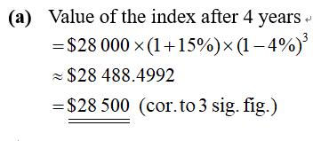
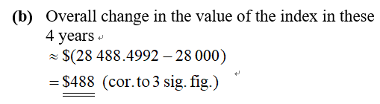

16. The net profit of a company declined at a rate of $1$2% per year from 2010 to 2012, then grew at a rate of 10% for every subsequent year. Given that the net profit of the company in 2015 is $5 000 000, find
(a) the net profit of the company in 2010,
(b) the overall percentage change in the net profit of the company from 2010 to 2015.

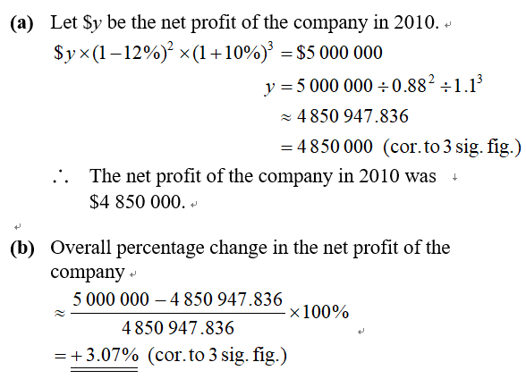


17. The monthly savings of a family decreased at a rate of 10% per month from May this year. If the total savings of the family for May, June and July were $40 650, what were the monthly saving of the family in May?

Let x be the amount of monthly savings of the family in May.
$$x+x\left(1-10\%\right)+x {\left(1-10\%\right)}^{2}=40650$$
$$x\left[1+\left(1-10\%\right)+ {\left(1-10\%\right)}^{2}\right]=40650$$
$$x\left[1+0.9+ 0.81\right]=40650 \\ x\left(2.71\right)=40650 \\ x=15000$$

$∴$ The monthly saving of the family in May were $15000

Checkpoint 3

A machine depreciates by r% each year. If its original value is $10 000 and becomes $6 400 one years later. Find the value of r.

$$6400=10000×\left(1-r\%\right)$$
$$0.64=1-r\%$$
$$r=20$$

18. The consumption of electricity by a family from May to august increase at a constant rate every month. In May and June, the family consumes 500 units and 575 units of electricity respectively. It is given that the charge for 1 unit of electricity is $0.7. Find the amount of electricity bill in August.
(Give the answers corrected to the nearest dollar.)

Let R% be the increase rate,
$575=500\left(1+\frac{R}{100}\right)$
$R=15$
Amount of electricity bill in August$=\$0.7×575{\left(1+\frac{15}{100}\right)}^{2}=\$532$
Q18-23
Percentage problem with constant rate
(find the original rate)

19. The population of town B is 110 000 now, and the population grows at a constant rate per year. If the population was 108 000 last year, find
(a) the annual growth rate,
(b) the population of town B 4 years later.

(b) The population of town B 4 years later
$=110 000×{\left(1+\frac{100}{54}\%\right)}^{4}$
$=118 377$
(a) Annual Growth Rate
$=\frac{110000-108000}{108000}×100\%$
$=1.85\%$ (corr. to 3 sig. fig.)

20. The value of a printer is decreased from $5 120 to $4 500 in 2 years, find the depreciation rate per year.

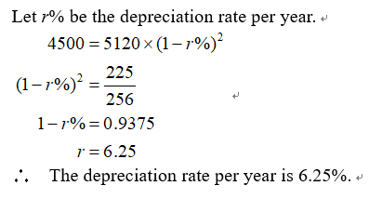

21. The value of a car is increased from $12 500 to $18 000 in 2 years, find the increased rate per year.
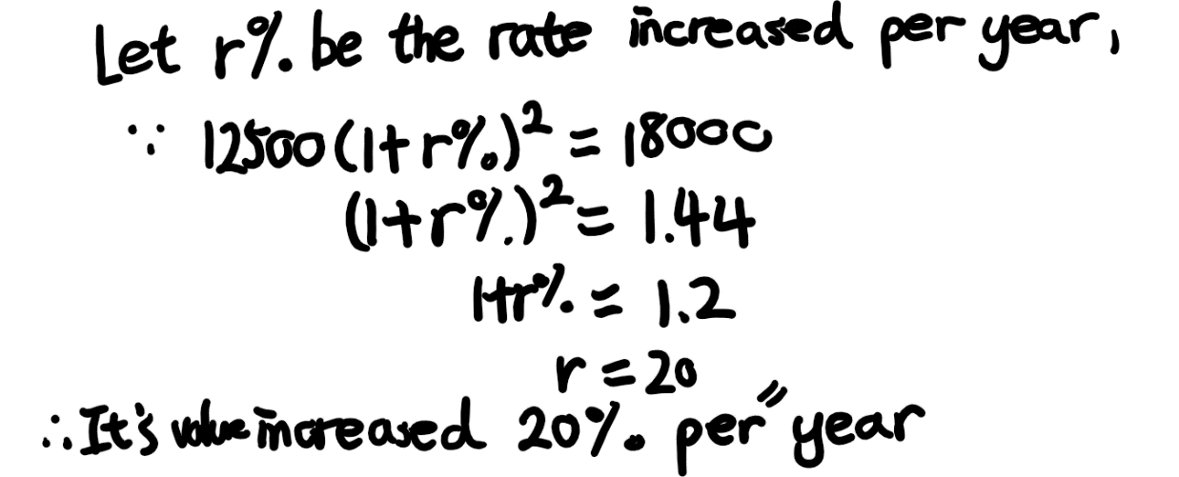

22. A package of mask which include 50 pieces is increased from $50 to $312.5 in 2 months, find the increased rate of a piece of mask per month. And calculate the price of a package of mask after 2 months.

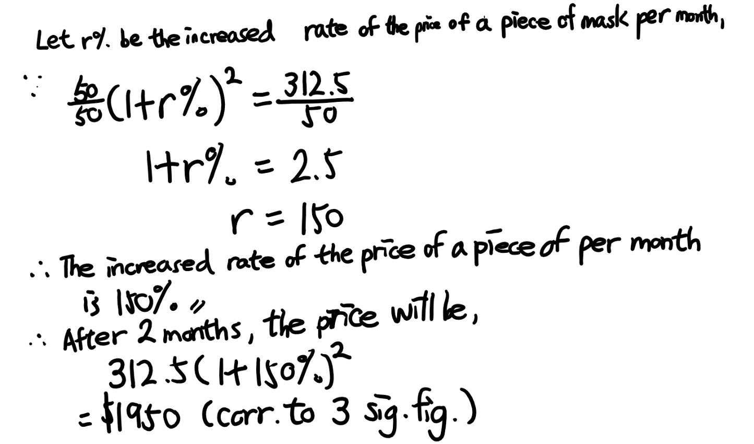

23. The population in City A of a is from 1 000 000 to 988 000 in 9 months, find the decreased rate per quarter.

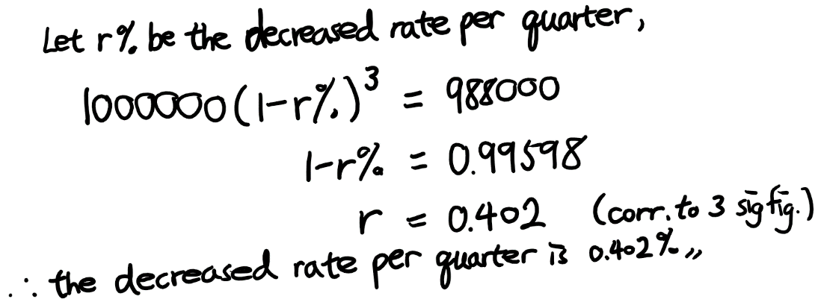

24. The weight of a fish was 115 g at the beginning of 2018. Then, its weight increased steadily at a rate of 2% per year from 2018 to 2021.
(a) Find the weight of the fish at the end of 2021.
(b) If the weight of the fish increases by 4% every year from 2022 onwards, find its weight at the end of 2023.
(Give the answers correct to the nearest g.)

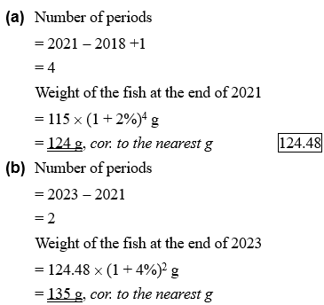


25. Kate bought a piano for $64 000 in 2020.
(a) If the value of the piano decreases by 6% every 6 months, find its value in 2022.
(b) If the value of the piano decreases at a rate of 12% every year, will its value in 2022 be the same as that found in (a)? Explain your answer. If not, what is the difference?
(Give the answers correct to the nearest dollar if necessary.)

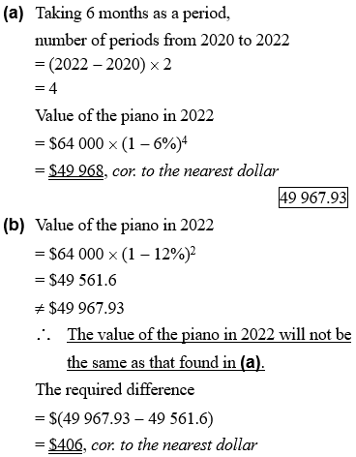


26. The value of an ebook reader depreciates by x% every 8 months. It is known that the present value of the reader is $1 100 and its value will be $770 after 8 months.
(a) Find the value of x.
(b) Find the depreciation of the ebook reader after 2 years as compared to the present value.

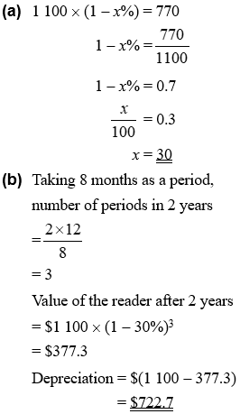


27. From 2019 to 2021, company A’s profit increased by 3% per year and company B’s profit increased by 4% per year. It is given that both companies made the same profit in 2021.
(a) Which company’s profit was higher in 2019? Explain your answer.
(b) If the difference of profits of companies A and B in 2019 was $40 000, find the profit of each company in 2021.
(Give the answer correct to the nearest dollar.)

